Getting Started with EROAD Assist

EROAD Assist is a mobile device application (app) that drivers use in addition to Ehubo. The app allows drivers to complete common tasks outside of their vehicles in a flexible manner.

Drivers access the app through smartphones and tablets to:

* Change hours-of-service duty status on and off.
* View and certify logs.
* Perform pre- and post-trip inspections.
* Log service requests for maintenance issues.
* Monitor their driving performance.
* View their ratings and rankings.

Contents

Administrative tasks 2

Install EROAD Assist in mobile devices 2

Enable EROAD Assist for drivers 3

Guide for drivers 5

Log on to EROAD Assist 6

EROAD Assist home screen 8

Change duty status 9

View and certify logs 10

Perform DVIR inspections 12

Resolve vehicle defects 14

Monitor driving performance 15

Log off EROAD Assist 17

# Administrative tasks

To use the EROAD Assist features, your organization’s service plan must include the associated modules. Contact EROAD Product Support at 1-877-503-7623 to learn more.

* Hours of Service: ELD module
* Leaderboard: Driver behavior module
* Inspect DVIR: Inspect In Vehicle module

In addition:

* Drivers must use a supported iOS or Android mobile device.
* For Inspect DVIR, drivers must belong to the same group (fleet) as the vehicle(s) they drive.

## Install EROAD Assist in mobile devices

You can install EROAD Assist on iOS smartphones and Android smartphones and tablets. EROAD notifies users and provides release notes when the EROAD Assist app updates to a new version.

To install EROAD Assist, direct drivers to download the app directly from the Google Play Store or Apple Store the same as they would any other app.

Alternatively, your organization may have policies in place to manage mobile apps, especially for company-controlled devices. Using a mobile device management tool, your technical support specialist can configure your devices to provide EROAD Assist to drivers. For assistance, call EROAD Product Support at 1-877-503-7623.

## Enable EROAD Assist for drivers

Enable the EROAD Assist app for drivers using the **Administration > My Organization** page. In addition, for driver vehicle inspection reports (DVIRs), enable inspections in the drivers' profiles.

**To enable EROAD Assist for drivers:**

**Note:** Client Administrator and Support permissions required.

1. On the EROAD main menu, select **Administration > My Organization**.
2. On the My Organization page, in the EROAD Assist App tile, select **Edit**.

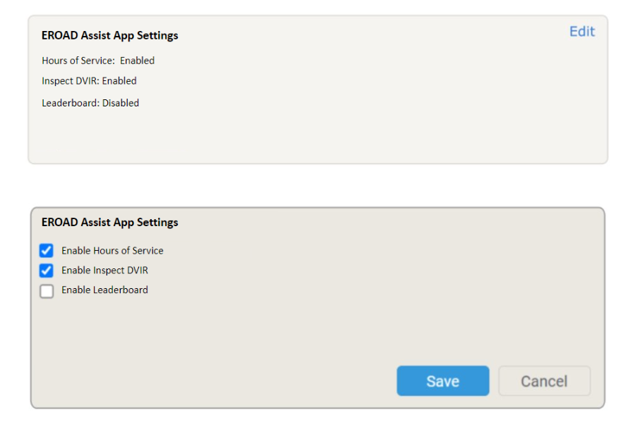

By default, the EROAD Assist App Settings tile displays with the Hours of Service feature enabled. Inspect DVIR and Leaderboard are also available if your plan includes the Inspect in Vehicle and DRIVER_BEHAVIOUR modules, respectively.

1. Select the EROAD Assist features you want drivers to use, and then select **Save**.

* Hours of Service (HoS): View HoS counters and ruleset, view and certify logs, and change duty status.
* Inspect DVIR: Perform pre- and post-trip inspections and log service requests for maintenance issues.
* Leaderboard: Monitor harsh driving events, ranking, and rating.

(continued)

1. (For enabled Inspect DVIR) On the EROAD main menu, select **Driver > Driver Profiles**.

Drivers will not see Inspect DVIR in their apps unless you enable the feature in their driver profiles. At the driver level, you can decide who can and cannot perform inspections using the app.

**Note**: The organizational setting overrides the profile setting.

1. Select a driver’s row.

The driver’s profile pane displays.

1. Graphical user interface, text, application, chat or text message

   Description automatically generatedIn the driver's profile pane, under Login, ensure that **Inspect App** is enabled.

**Note**: If the driver will use a personal mobile device to log on to the app, be sure the number is listed under the Personal section.

Remember to select **Submit** at the bottom of the pane if you make a change to the driver's profile.

# Guide for drivers

The EROAD Assist app provides a flexible way to perform common tasks, such as certifying your logs and performing inspections. Your administrator may deploy the app for you or ask you to download it from the Google Play Store or Apple Store, depending on your mobile device.

EROAD Assist provides access to three areas of interest for drivers:

* Hours of Service (HoS): Log on and off duty and certify logs.
* Inspect DVIR: Perform pre- and post-trip inspections, and request maintenance for vehicle defects.
* Leaderboard: Monitor your driving performance to improve safety.

**Note**: This assumes that your administrator has enabled all three features.

The following topics describe how to use EROAD Assist.

Log on to EROAD Assist 6

EROAD Assist home screen 8

Change duty status 9

View and certify logs 10

Perform DVIR inspections 12

Resolve vehicle defects 14

Monitor driving performance 15

Log off EROAD Assist 17

## Log on to EROAD Assist

When logging on to EROAD Assist, you can either use Ehubo or your mobile number for authentication. If logging on with your mobile number doesn't work, contact your administrator. The administrator may need to add the number to your driver profile in MyEROAD.

Log on with Ehubo

Authenticating with Ehubo is useful for companies with shared devices. When you log out of the app, the device is still authenticated, and the next driver simply selects their name from the list and logs on with their Ehubo logon pin (step 7 below).

**To log on with Ehubo**:

1. Access EROAD Assist on your mobile device.

The Welcome screen displays.

1. On the Welcome page, tap **Ehubo**.
2. Log on to Ehubo if you haven't already done so.
3. Graphical user interface, application

   Description automatically generatedOn the Ehubo home screen, tap **Driver**, and then tap **Retrieve Code**.

Ehubo responds with a six-digit code.

1. In the mobile device, tap **Enter code**.
2. Enter the six-digit code provided by Ehubo, and then tap **Next**.

To view the keyboard, tap inside the text field. You'll be prompted to retrieve a code again if too much time has passed. After entering the code, the app takes you to the Hello screen.

1. On the Hello screen, enter your Ehubo login pin.

The EROAD Assist home screen displays.

(continued)

Log on with mobile number

1. Graphical user interface, application

   Description automatically generatedAccess the app on your mobile device.

You will see the Welcome page.

1. On the Welcome page, tap **Mobile number**.
2. In the Mobile number field, enter your number, and then tap **Sign in**.

To view the keyboard, tap inside the field. After signing in, EROAD Assist responds with a text message containing a six-digit code.

1. In the code field, enter the six-digit code, and then tap **Verify**.

EROAD Assist issues an error if too much time has passed. If this occurs, tap **Resend** to receive a new code. After entering the code, the app takes you to the Hello screen.

1. On the Hello screen, enter your Ehubo login.

The EROAD Assist home screen displays.

## EROAD Assist home screen

After logging into EROAD Assist, you see the home screen, where you can:

1. Graphical user interface, diagram, application

   Description automatically generatedAccess your driver profile, where you log out of the app.
2. View your current duty status. Tap this area (called a widget) to take you to the Change duty status screen.
3. View your Hours of Service counters. Tap this widget to take you to the Hours of Service screen.
4. Monitor your driving performance. Scroll down to see your performance rating.
5. Access features from the **Menu**:

* **ELD**: Go to the Hours of Service Logs screen, where you view and certify logs.
* **DVIR**: Go to the DVIR screen, where you begin an inspection and review defects.
* **Leaderboard**: Go to the Leaderboard screen, where you view harsh driving events for the day.

At the top of the various EROAD Assist screens, a house icon returns you to the home screen or a back arrow displays the previous screen.

## Change duty status

EROAD Assist enables you to change your duty status between on and off when away from Ehubo. For other duty statuses, use Ehubo.

**To change your duty status**:

**Note**: An error displays if you have not logged off Ehubo before saving a new duty status. After logging off Ehubo, there may be a brief time lag before EROAD Assist allows you to save a new duty status.

1. Chart

   Description automatically generated with medium confidenceOn the EROAD Assist home screen, tap the current duty status widget.

The Change duty status screen displays. You can also access this screen from the Hours of Service screen.

1. Tap **OFF** or **ON**.
2. In the **Location** field, enter your current location.

This field is required. Tap inside the field to access the keyboard.

1. (Optional) In the Remark field, enter a remark.

You can type the remark or tap one of the suggested remarks.

1. Tap **Save**.

Ehubo and EROAD Assist synchronize with each other. The duty status change will display in your logs after Ehubo completes a remote event synchronization.

## View and certify logs

You can certify the current day's log and also retroactively bulk certify all uncertified logs.

**To view and certify the current day's log**:

1. On the home screen, tap **Menu > ELD**.

The Logs screen displays with the current day's log, where you can:

1. Navigate between days to view logs.

2. Certify the log shown on the screen.

3. View form and manner details.

4. View duty status details.

5. View Hours of Service counters and current ruleset, and  
 change your duty status.

6. View all uncertified logs and certify them.

1. Tap **Certify > Agree**.

You have certified the log and its status transmits to MyEROAD.

Ehubo and EROAD Assist synchronize with each other. The certified days will display in your logs after Ehubo completes a remote event synchronization.

(continued)

**To bulk certify logs**:

1. On the home screen, tap **Menu > ELD**.
2. On the Logs screen, tap **CERTIFY**.

The Uncertified Logs screen displays. As needed, tap the expand arrow for a particular log to view its details. Tap the back arrow to return to this screen.

1. If all the logs are correct, tap **Select All > Certify *n* Log(s) > Agree**.

**Note:** If a log is incorrect, edit it using Ehubo before certifying it.

You can use this screen to certify individual logs, too.

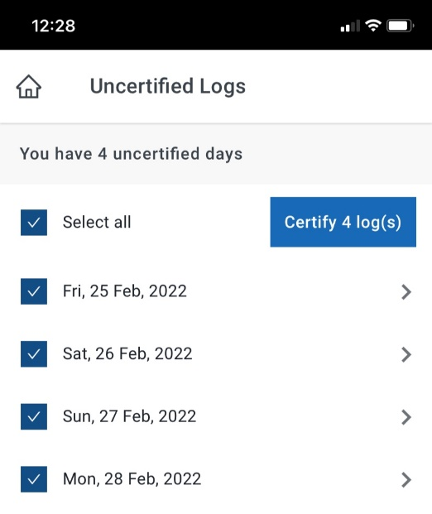

## Perform DVIR inspections

EROAD Assist inspections comply with the requirements for driver vehicle inspection reports (DVIRs).

**To perform an inspection, do the following**:

1. Graphical user interface, application

   Description automatically generatedOn the EROAD Assist home screen, tap **Menu > DVIR**.

The DVIR screen displays. It lists the vehicles you have recently selected and whether they have unrepaired defects associated with them. The app warns you when a vehicle is unsafe to drive.

On this screen, you can:

1. Select a new machine. The app adds it to the recently selected  
 list.

2. Select a listed machine. The app takes you to the DVIR screen.

3. Go to the DVIR screen, where you start or continue an  
 inspection.

4. Go to the Defects screen, were you view and resolve defects.

1. Under Recently selected vehicles, tap a vehicle.

-or-

If this is your first time performing an inspection with the app or your vehicle is not listed, do the following:

* 1. Tap **Add Vehicle**.
  2. On the Machines screen, tap a listed vehicle or start typing the vehicle name in the search field until it appears in the list for you to tap.

**Note:** The vehicle must exist in your group (fleet). Contact your administrator if the vehicle does not appear when you search for it.

(continued)

1. Graphical user interface, application

   Description automatically generated with medium confidenceOn the DVIR screen, tap **Pre Trip** or **Post Trip**.

The app reminds you to review any defects. Refer to Resolve vehicle defects for details. After completing this task, the app returns you to this point in the inspection.

To cancel the current inspection, tap the “X”.

1. On the next screen, do one of the following:

* Tap **No Defects** if you know the vehicle has no *new* defects. (It may have previously logged defects that still require repair or attention.) The app takes you to the Summary screen. Tap **Submit DVIR**. You have completed the inspection.
* Tap **Defect** to perform the inspection. The Mark all defects screen displays.

1. On the Mark all defects screen (not shown), inspect the listed vehicle components for defects, and if there is a new defect, tap **Issue** beside the defective component.

The Action Defect screen displays.

1. Graphical user interface, funnel chart

   Description automatically generatedIn the Action Defect screen, tap the options that describe the defect.
2. (Optional) Tap **Take a photo** and use your device's camera to photograph the defect.

The app requests access to your mobile device's camera if you haven't already granted access. The photo appears on the Action Defect screen. To delete it, tap the image and then tap the Trash icon.

1. Tap **Done**.

The app returns you to the Mark all defects screen.

1. Continue the inspection and when complete, tap **Next**.

The Summary screen displays.

1. On the Summary screen, verify that the listed defects (if any) are correct, and tap **Submit DVIR**.

The app sends the inspection report to MyEROAD, where administrators can monitor repairs.

## Resolve vehicle defects

When you begin a vehicle inspection using EROAD Assist, the app directs you to review previous unrepaired defects (if any) and update them to **Repaired**before proceeding.  
  
After tapping**Menu > DVIR > *Vehicle Name* > Pre Trip** or **Post Trip** to begin an inspection, you will see the Please review defects screen.

**To resolve defects:**

1. Tap **Review**.
2. On the Review Defect screen, tap **Still Failed** or **Repaired**.

The app shows you the next defect (if any). When you are done, it returns you to where you left off in the inspection.

You can also resolve defects without starting an inspection first.

1. On the home screen, go to **Menu > DVIR** and tap **DEFECTS**.

The Defects screen displays, where you see a summary of reported and repaired defects for all listed vehicles. For each defect, the status shows **Attention**, **Failed Safe**, or **Failed not safe**.

1. Tap a reported defect that has been repaired.
2. Graphical user interface, application

   Description automatically generatedOn the next screen, tap **Repaired**.

The app returns you to the Defects page, where you see the note “Repair confirmed” next to the defect.

Repaired defects drop off the list after 24 hours.

## Monitor driving performance

EROAD Assist provides a Leaderboard for monitoring your driving patterns so that you can improve your performance and stay safe. The Leaderboard shows your score if you traveled within the previous 28 days.

After logging in, on the home screen, scroll down to view the Leaderboard.

Tap the white Leaderboard widget to go to the Leaderboard screen, where you can view details. You can also access this screen by tapping **Menu**.

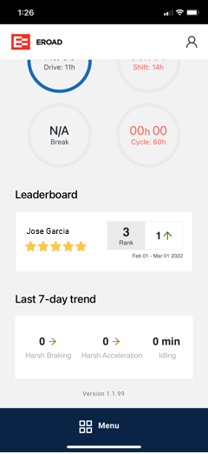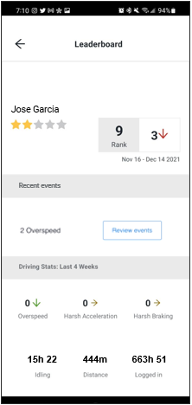

Tap **Review events** to view where and when you incurred harsh driving events from the last 24-hour period.  
  
Under Driving Stats, the arrows next to the risky driving behaviors indicate your performance trend: improved (green), no change (brown), worsened (red).

(continued)

What is the star rating?

For the star rating shown in yellow, MyEROAD calculates the scores relative to the scores of all drivers across the EROAD driving population. Ratings are based on the following "grading" curve:

* Five stars: top 10% driver scores
* Four stars: the next lower 25%
* Three stars: the next lower 40%
* Two stars: the next lower 24%
* One star: lowest 1% driver scores

Consider three stars an average grade, similar to a "C" for students.

Scores are based on the following risky driving behaviors. The higher the frequency and severity of the behavior, the greater the negative impact on your score.

* Overspeeding
* Harsh braking
* Harsh acceleration

**Note**: Research shows that speeding is a leading risk factor for collisions, and therefore increases the severity of any driving event. High-severity events knock scores down further than less severe events. Remember that doubling vehicle speed means it takes at least four times the distance to stop.

What is the rank?

The rank shows your performance relative to the other drivers in your organization. The box next to the Rank box displays your performance trend. For example, in the previous image, Mike Smith's rank fell three spots since the previous month; now he is ranked ninth in his organization.

## Log off EROAD Assist

Log off the app from your profile page.

**To log off EROAD Assist:**

1. On your current screen, tap the Home icon located in the upper left corner of the screen.

Depending on where you are, you may first need to tap the back arrow.

1. On the home screen, tap the person icon located in the upper right corner of the screen.

Your Driver Profile page displays.

1. Tap **Log out >** **Yes**.

The app returns you to the logon page. If you logged on to a shared device using Ehubo, you see a list of drivers.